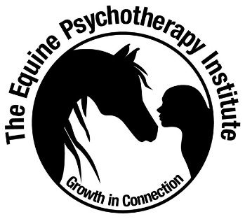
The Equine Psychotherapy Institute
Student Code of Ethics

The EPI Student
- Will support their own and their fellow students’ growth, psychological wellbeing and social-emotional learning.
- Will respect the inherent value and dignity of their fellow students and animals and will endeavour to keep themselves, other students and animals safe, supporting the best interests of all present during the training process.
- Will demonstrate an ongoing commitment to I-Thou Interspecies Relating principles and an ongoing commitment to animals’ physical, psychological, behavioural and herd needs being met, in and out of session.
- Will always regard the safety of all present during training and practice sessions, providing safe experiences, safe facilities, and appropriate animal – human experiences.
- Will maintain confidentiality of all personal matters discussed in the training environment and support student autonomy and self-determination.
- Will continually reflect and evaluate practice-client therapeutic goals or learning goals, client progress, and even in self practice situations, refer on when necessary.
- Will treat other professionals with respect and integrity.
- Will share information and practice that benefits the professionalism of the animal assisted psychotherapy and animal assisted learning fields in general.
- Will seek to continually be aware of their own competencies, limitations and personal issues that may impact their work, with an ongoing commitment to continuing personal psychotherapy and professional development.
- Will not misrepresent their qualifications, training or competencies. For example, if you are not registered as a mental health clinician, counsellor or psychotherapist (and have trained and certified as an Animal Assisted Learning practitioner), you will not refer to your work as psychotherapy or therapy, or imply (through omission) that your work is therapy or therapeutic in nature.
- Will remain within scope of practice as a student of the Institute and will only present themselves as a practitioner once certified with the Institute.
- Will refer to ‘Animal Assisted Learning’ explicitly (if trained and certified as an EAL practitioner) in all business, promotional and media related activities (i.e. websites, articles, cards, networking with others) to - purposefully build the profile of EAL, support the community to understand the unique value of social-emotional skills building and professional skills development (i.e. leadership skills), and, to further support the community to understand the “non-therapy” scope of practice in EAL.
- Will adhere to the 7 Principles of Practice, including offering animal assisted services that are – relationship-based, holistic and phenomenological, ethical, driven by EPI model theory of change, demonstrates a commitment to ongoing personal work and continuing professional development (10 hours per annum), and engages clients in Animal Wisdom psycho-education, understanding animals as our models and teachers.
- Will follow state and national laws re scope of practice and business.
- Will follow professional membership and registration code of ethics, legal and scope of practice requirements (i.e. psychology, social work, nursing etc. if a psychologist, social worker, nurse etc.).
- Will never deceive or participate in dishonest or illegal activities.
- Will not engage in personal conduct that may harm their status or the field’s reputation for professionalism and excellence.
- Will continually be committed to ethical decision-making and boundary choices that that keep the wellbeing of themselves, practice clients and fellow students primary. Students will continually reflect on and attend to dual role issues and boundary crossings (i.e. combining friendship and professional service provision, offering services without a beginning or end time, touching without consent, self-disclosure when it arguably serves the needs of the practitioner). Professional boundaries are essential to professional service provision, and practitioners will always seek supervision in cases of boundary concerns.
- Will maintain the highest standards of personal and professional integrity.
- Will not utilise any of the intellectual property provided, the EPI model or their position as a student for any reason, including (but not limited to) conducting their own training in Animal or Animal Assisted Psychotherapy/ Learning or Interventions, providing content to other training organisations or persons not affiliated with the Institute or any other activity not explicitly authorised by the Institute.

Agreement to abide by Student Code of Ethics
Date:
Signature: |  | Name:

