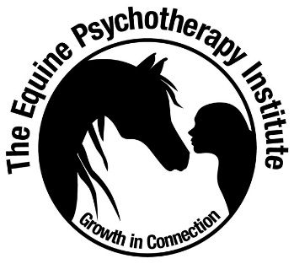
The Equine Psychotherapy Institute
Code of Ethics & Code of Conduct

The EPI Practitioner
- Will provide the highest quality of service in supporting their client’s growth, psychological wellbeing and social-emotional learning.
- Will respect the inherent value and dignity of their clients and horses and will endeavour to keep clients and horses safe, supporting the best interests of the client and horses.
- Will demonstrate an ongoing commitment to I-Thou Horsemanship principles and an ongoing commitment to horses’ physical, psychological, behavioural and herd needs being met, in and out of session.
- Will always regard the safety of clients, providing safe experiences, safe facilities, and appropriate horse – human experiences.
- Will maintain confidentiality, client autonomy and self-determination.
- Will continually reflect and evaluate client therapeutic goals or learning goals, client progress, and refer on when necessary.
- Will treat other professionals with respect and integrity.
- Will share information and practice that benefits the professionalism of the equine assisted psychotherapy and equine assisted learning fields in general.
- Will seek to continually be aware of their own competencies, limitations and personal issues that may impact their work, with an ongoing commitment to continuing personal psychotherapy and professional development.
- Will not misrepresent their qualifications, training or competencies. For example, if you are not registered as a mental health clinician, counsellor or psychotherapist (and have trained and certified as an Equine Assisted Learning practitioner), you will not refer to your work as psychotherapy or therapy, or imply (through omission) that your work is therapy or therapeutic in nature.
- Will refer to ‘Equine Assisted Learning’ explicitly (if trained and certified as an EAL practitioner) in all business, promotional and media related activities (i.e. websites, articles, cards, networking with others) to - purposefully build the profile of EAL, support the community to understand the unique value of social-emotional skills building and professional skills development (i.e. leadership skills), and, to further support the community to understand the “non-therapy” scope of practice in EAL.
- Will adhere to the 7 Principles of Practice, including offering equine assisted services that are – relationship-based, holistic and phenomenological, ethical, driven by EPI model theory of change, demonstrates a commitment to ongoing personal work and continuing professional development (10 hours per annum), and engages clients in Horse Wisdom psycho-education, understanding horses as our models and teachers.
- Will display The Equine Psychotherapy Institute Certified EAP Practitioner or The Equine Psychotherapy Institute EAL Practitioner logo on relevant business and promotional materials, if certified EAP or EAL Practitioner.
- Will maintain up to date waivers, policies and procedures, appropriate Insurance and First Aid certification.
- Will follow state and national laws re scope of practice and business.
- Will follow professional membership and registration code of ethics, legal and scope of practice requirements (i.e. psychology, social work, nursing etc. if a psychologist, social worker, nurse etc.).
- Will never deceive or participate in dishonest or illegal activities.
- Will not engage in personal conduct that may harm their status or the field’s reputation for professionalism and excellence.
- Will continually be committed to ethical decision-making and boundary choices that that keep the wellbeing of the client primary. Practitioners will continually reflect on and attend to dual role issues and boundary crossings (i.e. combining friendship and professional service provision, offering services without a beginning or end time, touching without consent, self-disclosure when it arguably serves the needs of the practitioner). Professional boundaries are essential to professional service provision, and practitioners will always seek supervision in cases of boundary concerns.
- Will maintain the highest standards of personal and professional integrity.
Agreement to abide by Code of Ethics and Code of Conduct
Signature:
Date:

